|  |  |
| --- | --- |
| [QA6T-37] [Spelling/Grammar Errors](https://dmutah.atlassian.net/browse/QA6T-37) Created: 19/Jul/18  Updated: 19/Jul/18 | |
| **Status:** | Open |
| **Project:** | [QA6 Tansey](https://dmutah.atlassian.net/secure/BrowseProject.jspa?id=10121) |
| **Component/s:** | None |
| **Affects Version/s:** | None |
| **Fix Version/s:** | None |

|  |  |  |  |
| --- | --- | --- | --- |
| **Type:** | Bug | **Priority:** | Medium |
| **Reporter:** | [Tansey Sussex](https://dmutah.atlassian.net/secure/ViewProfile.jspa?name=tsussex) | **Assignee:** | Unassigned |
| **Resolution:** | Unresolved | **Votes:** | 0 |
| **Labels:** | None | | |
| **Remaining Estimate:** | Not Specified | | |
| **Time Spent:** | Not Specified | | |
| **Original Estimate:** | Not Specified | | |

|  |  |
| --- | --- |
| **Attachments:** | Deck Message Spelling-Grammar Error.JPG     Privacy Policy Capitalization.JPG     Terms of Use Spelling Error.JPG     spelling error in Welcome.JPG |
| **Steps to Reproduce:** | 1. From account creation page.    * Observe spelling error in the Study section of the Welcome page (photo attached) 2. From home page 3. Access Privacy Policy    * Observe capitalization errors (photo attached) 4. Access Terms of Use    * Observe spacing errors (photo attached) 5. Access the Decks page    * Observe the spelling error in the deck description section (photo attached) |
| **Expected Result:** | App is free of spelling and grammatical errors. |
| **Actual Result:** | Spelling, formatting, and grammatical errors found. |
| **Epic Link:** | [Cards Testing](https://dmutah.atlassian.net/browse/PROJ-18) |

|  |  |
| --- | --- |
| **Description** |  |

|  |
| --- |
| * Spelling/Grammatical errors in the app. * Refer to test case [QA6T-24](https://dmutah.atlassian.net/browse/QA6T-24) Open |

Generated at Wed Aug 08 23:22:51 UTC 2018 by Tansey Sussex using Jira 1001.0.0-SNAPSHOT#100090-sha1:e1f36159049942a868292ec329caab3852405e7e.

Deck Message Spelling-Grammar Error

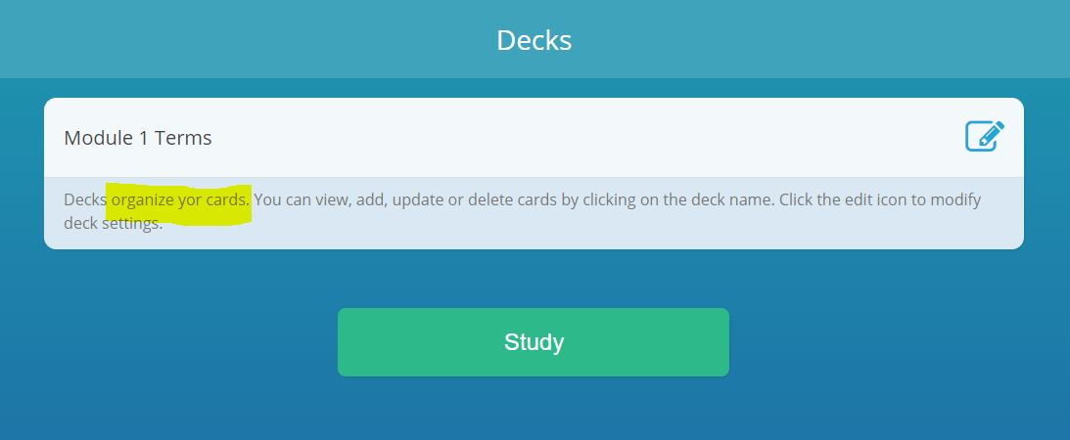

Privacy Policy Capitalization

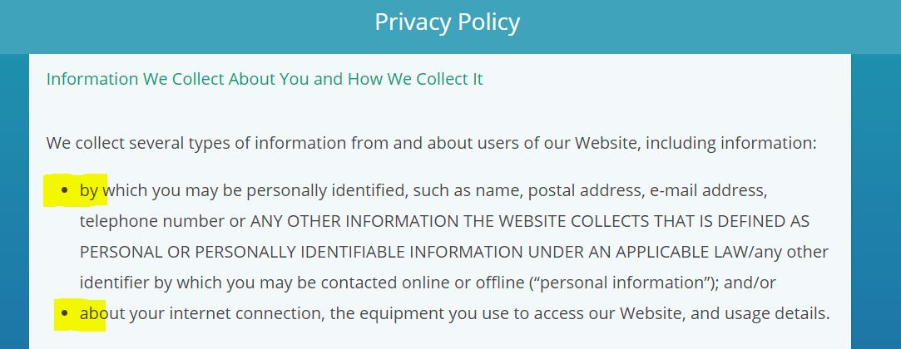

Spelling Error in Welcome

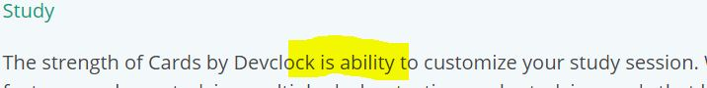

Terms of Use Spelling Error

